10.62: At the point of contact, the wall exerts a friction force f directed downward and a normal force n directed to the right. This is a situation where the net force on the roll is zero, but the net torque is not zero, so balancing torques would not be correct. Balancing vertical forces, 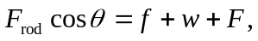and balacing horizontal forces 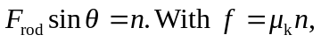 these equations become

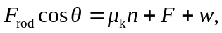
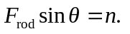

(a) Eliminating n and solving for 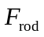 gives
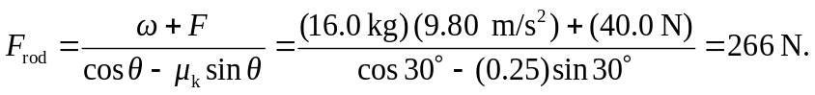

b) With respect to the center of the roll, the rod and the normal force exert zero torque. The magnitude of the net torque is 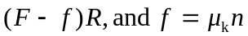 may be found insertion of the value found for 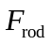 into either of the above relations; i.e., 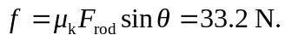Then,
